| **SEO detail** | **Content** | **Character count/score** |
| --- | --- | --- |
| **Meta title** | Visitor to Canada Insurance: Compare Quotes | [Domain Name]  OR  Best Visitor to Canada Insurance Plans | Compare & Save | 51/60  55/60 |
| **Meta description** | Compare affordable Visitor to Canada insurance plans from 30+ trusted providers. Get customized coverage for tourists, students, & Super Visa in minutes!  OR  Find the best Visitor to Canada insurance with [Domain Name]. Compare quotes from top providers for tourists, workers, and Super Visa applicants today! | 153/160  151/160 |

# **Travel Smart. Protect Your Visit to Canada.**

# *Protect your visit to Canada with affordable, customized visitor insurance plans from 30+ trusted providers.*

OR

# **Visitor to Canada Insurance: Compare Quotes & Find the Best Coverage**

*Protect your visit to Canada with affordable, customized visitor insurance plans from 30+ trusted providers.*



## **Your trusted partner for Visitor to Canada Insurance**

Whether you’re visiting Canada for leisure, study, work, or to reunite with your loved ones, having Visitor to Canada insurance is crucial. Canada's healthcare system does not cover non-residents, and a single hospital visit can cost over $2,500!

At *[domain name]*, we promise you the best visitor insurance plans for Canada within minutes, and at affordable rates. We specialize in customized Visitor to Canada insurance plans to meet the unique needs of tourists, international students, temporary workers, Super Visa applicants, and more.

Our easy-to-use platform helps you compare plans from trusted Canadian providers and find the best coverage, so you can travel with complete peace of mind.



LONGER WIDGET [Get an instant quote]

## **Why choose us**

We make finding the right visitor insurance for Canada simple, fast, and reliable. Here’s why you should trust us:

* **Comprehensive comparison**Instantly access quotes from multiple top Canadian insurance providers—all in one place!
* **Save time & money**Quickly compare competitive rates to find plans that offer the best value for your needs
* **Customized options**Choose from plans designed specifically for tourists, international students, temporary workers, and Super Visa applicants
* **Transparent information**We present clear, easy-to-understand plan details and costs—no hidden fees or surprises
* **Easy & secure online process**Get quotes and purchase your policy conveniently and safely from anywhere
* **Expert support**Our licensed advisors and customer service team are ready to help you choose the right coverage and answer your questions

### **What is Visitor to Canada Insurance?**

Canada’s provincial healthcare does not cover visitors, which makes visitor insurance essential for anyone traveling to Canada. Visitor to Canada insurance protects your parents, relatives, and other guests from unexpected medical emergencies and travel-related expenses during their stay.

There are two main types of visitor insurance:

* **Medical insurance for visitors to Canada** This coverage helps pay for medical treatment if you fall ill or get injured while visiting. It also covers emergency medical transportation, including medical evacuation to a hospital in another country if necessary. This is the most commonly purchased type of visitor insurance
* **Trip cancellation and interruption insurance** This insurance reimburses you for trip costs if you need to cancel or interrupt your travel due to unforeseen events like illness, severe weather, lost baggage, or transportation delays

Together, these coverages provide peace of mind, ensuring visitors are protected against costly emergencies and travel disruptions while in Canada.

## **Why do you need visitor insurance in Canada?**

Emergency medical insurance in Canada can save you thousands. As a non-resident, you’re responsible for all healthcare costs, including ER visits that often exceed $3,000.

Visitor health insurance Canada covers sudden expenses like hospitalization, doctor visits, diagnostics, and ambulances and helps you avoid unexpected bills during your stay.

## **Who needs travel insurance for visitors to Canada?**

We customize visitor insurance to protect every kind of traveller in Canada. Whether you’re a tourist, international student, temporary worker, or simply visiting family, our plans cover emergency medical care so you can focus on your trip, not on unexpected bills.

### **Visitor insurance for tourists**

Insurance for tourists in Canada covers emergency medical care, so you can explore the country stress-free

### **Emergency medical insurance for international students**

Before provincial health plans kick in (or if you're not eligible), international student insurance Canada provides essential protection for doctor visits and hospital care

### **Visitor to Canada insurance for temporary workers & IEC participants**

Temporary worker insurance Canada and IEC (International Experience Canada) insurance protect those in Canada on work permits with plans designed for temporary stays

### **Super Visa insurance in Canada**

To qualify, you need Super Visa insurance Canada with at least $100,000 in coverage from a Canadian provider, valid for a year

### **Visitor insurance for parents and grandparents**

Reunions should be joyful, not stressful. Our visitor insurance for parents and grandparents in Canada covers both short trips and long Super Visa stays

## **Compare the best visitor insurance plans in Canada**

**One platform. All the top Canadian visitor insurance providers.**

[Domain name] makes it easy to **compare visitor insurance quotes in Canada**, saving time and money. In 2024, 82% of users said multi-provider comparisons helped them find better coverage faster.

### **Which companies offer the best health insurance plans for visitors to Canada?**

Several top insurance providers offer affordable visitor insurance to Canada, including Manulife, Tugo, Allianz, Travelance, 21st Century, GMS, and more. Each company provides different premiums, coverage options, deductibles, and policy features to suit various needs.

At [Domain Name], we partner with Canada’s best visitor insurance providers to help you compare and choose the right plan with confidence.

**Choose from Canada’s leading visitor insurance companies:**

* Manulife
* Tugo (iA Financial Group)
* Group Medical Services (GMS)
* Allianz
* 21st Century Travel Insurance Limited
* Destination Canada
* Travelance
* Secure Travel

[Domain name] gives you access to competitive rates and comprehensive coverage options from trusted providers—all in one place.

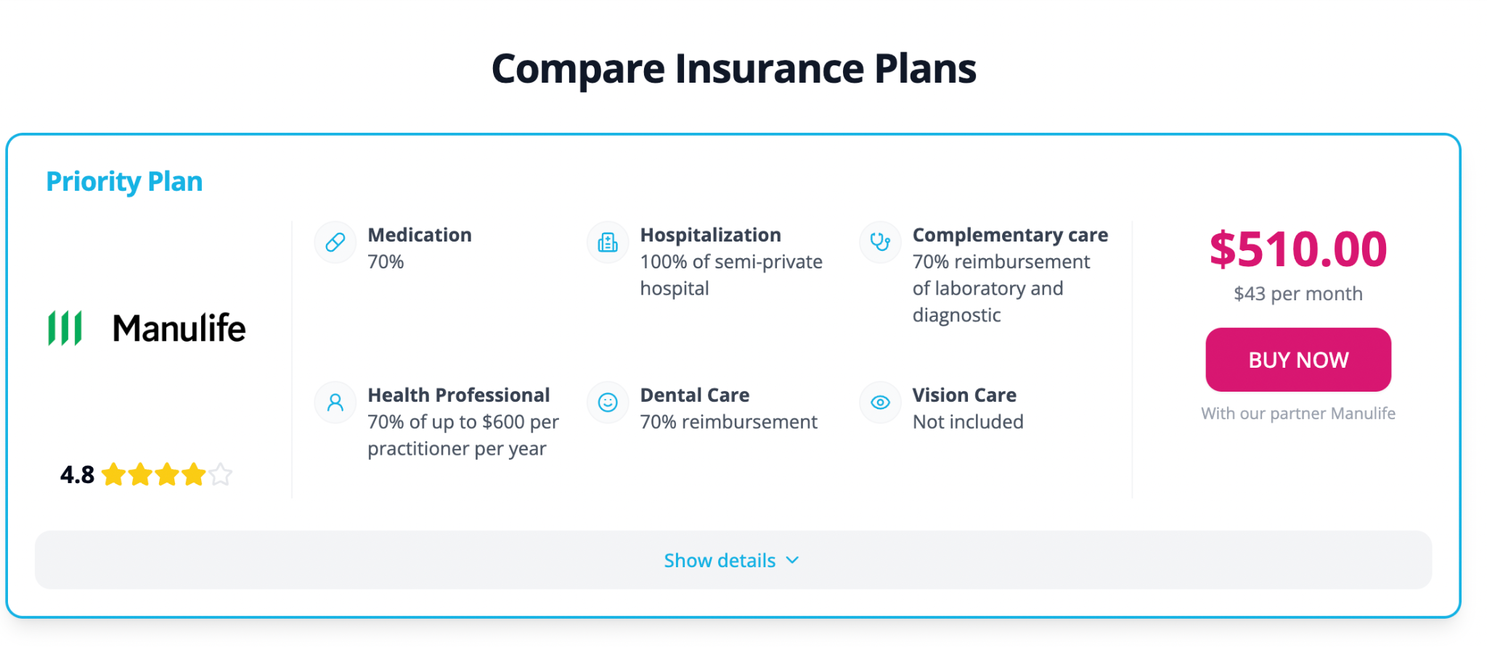

### **What a typical visitor insurance plan covers**

* **Emergency medical expenses**: Covers hospitalization, doctor visits, lab tests, and ambulance services for sudden illnesses or injuries
* **Prescription drugs**: Provides medication coverage for emergencies included in your plan
* **Emergency dental care**: Offers immediate relief for dental pain or accidental injuries during your trip
* **Medical evacuation & repatriation**: Ensures safe transfer to a better medical facility or return home if treatment is unavailable locally
* **Accidental Death & Dismemberment (AD&D)**: Lump-sum protection in the event of accidental death or serious injury
* **Coverage for pre-existing medical conditions**:Includes stable pre-existing conditions with coverage eligibility typically after 90 to 180 days of stability

Add-ons available include travel interruption insurance for Canada visitors and baggage loss insurance for Canada visitors.

## **How to buy visitor insurance for Canada?**

**Simple 4-step process tailored to your trip.**

1. **Submit your details:** Enter your age, trip dates, number of travellers, and destination
2. **Pick coverage needs:** Choose requirements like Super Visa insurance, pre-existing condition coverage, and policy limits
3. **Compare quotes instantly:** View multiple personalized options side-by-side
4. **Purchase your plan online:** Purchase your chosen policy directly through [Domain name] in minutes

## **When to purchase visitor to Canada**

For the best protection, buy your travel insurance as soon as you confirm your plans to visit Canada. Purchasing early offers significant advantages over waiting until after you arrive.

| **Buying before arrival** | **Buying after arrival** |
| --- | --- |
| Coverage starts the moment you leave your home country | Coverage often begins only after a waiting period of 48–72 hours |
| No waiting periods before your insurance takes effect | You may face a waiting period before benefits apply |
| Protects you throughout your entire journey, including flights | Higher premiums are common when buying after arrival |
| Generally more affordable rates | Limited options for covering pre-existing conditions |
| Gives you peace of mind from the start of your trip | Risk of being uninsured during the initial days of your stay |
| Includes coverage for emergencies that may occur while traveling | May not cover conditions that develop during the waiting period |

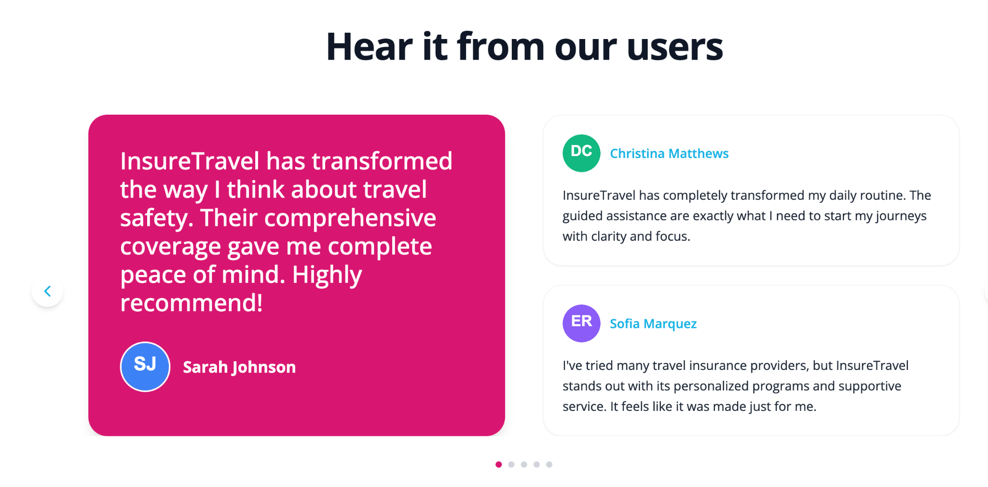

## **Frequently asked questions**

Quick answers for smart decisions.

## **Visitors to Canada insurance requirements explained**

Get clear, confident coverage by understanding the essential insurance requirements for visitors to Canada. Knowing the key terms helps you choose the right plan and avoid surprises when you need care. Here’s a quick guide to the most important insurance concepts you should know before you travel.

**Understand your visitor to Canada coverage with confidence**

* **Deductible**: What you pay before insurance kicks in
* **Policy maximum**: The most your plan will cover
* **Premium**: Cost of the plan
* **Exclusions**: What’s not covered
* **Waiting period**: Time before benefits begin (if applicable)
* **Eligibility criteria**: Who qualifies
* **Claims process**: How to get reimbursed